Docker

Creator r : Amruta Pednekar

amruta.jadhav1@gmil.com

horizontal line

A tool to automate the deployment of the application in containers so that the application can work in different environments.

# Installation on Ubuntu

* <https://www.simplilearn.com/tutorials/docker-tutorial/how-to-install-docker-on-ubuntu>
* Open terminal
* Remove any docker file running
  + $ sudo apt-get remove docker docker-engine docker.io
* Update system
  + sudo apt-get update
* Install docker and its dependencies
  + sudo apt install docker.io
  + sudo snap install docker
  + docker — versions
* Pull an image from docker hub
  + sudo docker run hello-world
* Check the docker image
  + sudo docker images
* Display all docker containers
  + sudo docker ps -a
* Check for containers in running state
  + sudo docker ps

# Installation on Windows

* <https://docs.docker.com/desktop/windows/install/>
* Download Docker desktop for windows
  + https://hub.docker.com/editions/community/docker-ce-desktop-windows/
* Run downloaded .exe installer
* Check below option
  + **Install required Windows components for WSL 2**
  + **Add shortcut to desktop**
* Install
* After installation , it will ask to restart
* Open installed app Docker Desktop
* Accept Terms
* Open
* 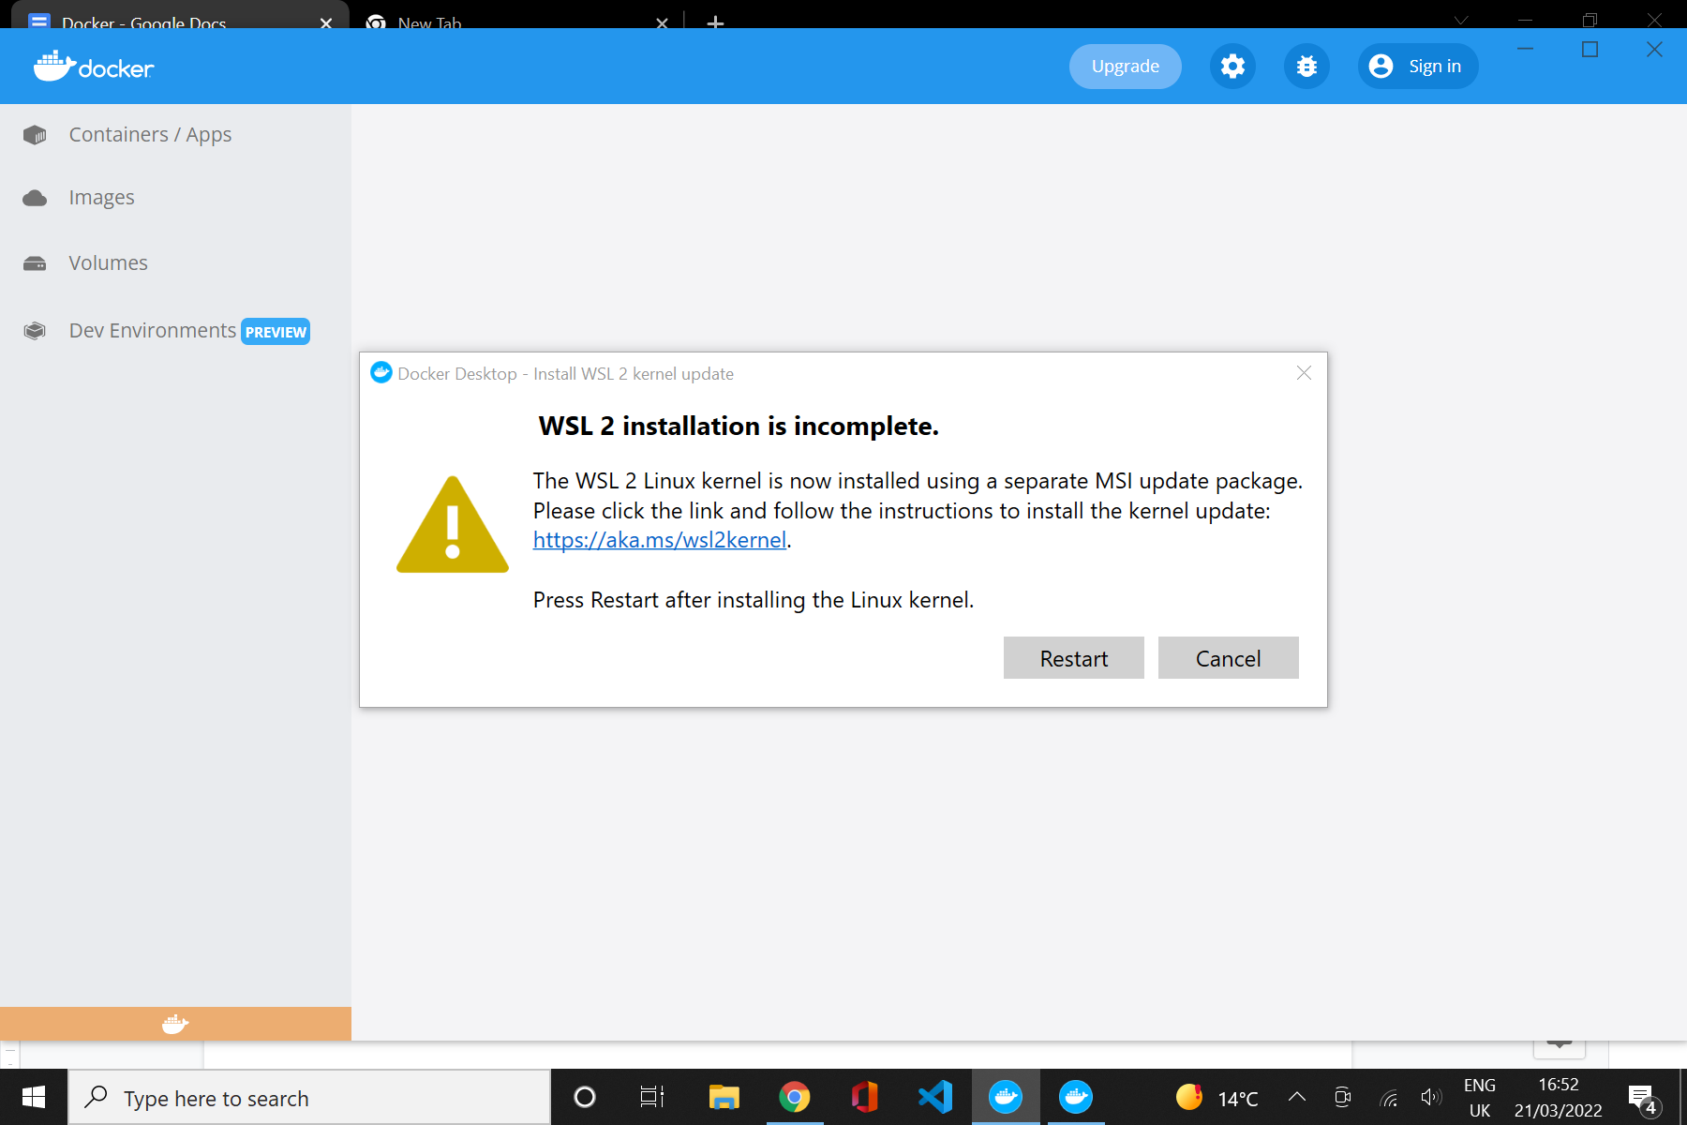
* After opening Docker, if you get above message
  + Click on to hyperlink
  + Download WSL2 from that hyperlink
  + <https://wslstorestorage.blob.core.windows.net/wslblob/wsl_update_x64.msi>
  + Install
  + Restart

# Docker Tutorial

**Prerequisites** :

Create an account on <https://hub.docker.com/>

Login to Docker Desktop

**Docker container**

* Clone repository by running Git in container
  + docker run --name repo alpine/git clone https://github.com/docker/getting-started.git
  + It pulls the image from repository
* Build the image
  + It provides all the files and code your container needs
  + cd getting-started
  + docker build .
  + OR
  + docker build -t docker101tutorial .
* Run the container
  + docker run -d -p 80:80 --name docker-tutorial docker101tutorial
* Save and share this image on Docker hub
  + docker tag docker101tutorial amrutapednekar/docker101tutorial
  + docker push amrutapednekar/docker101tutorial

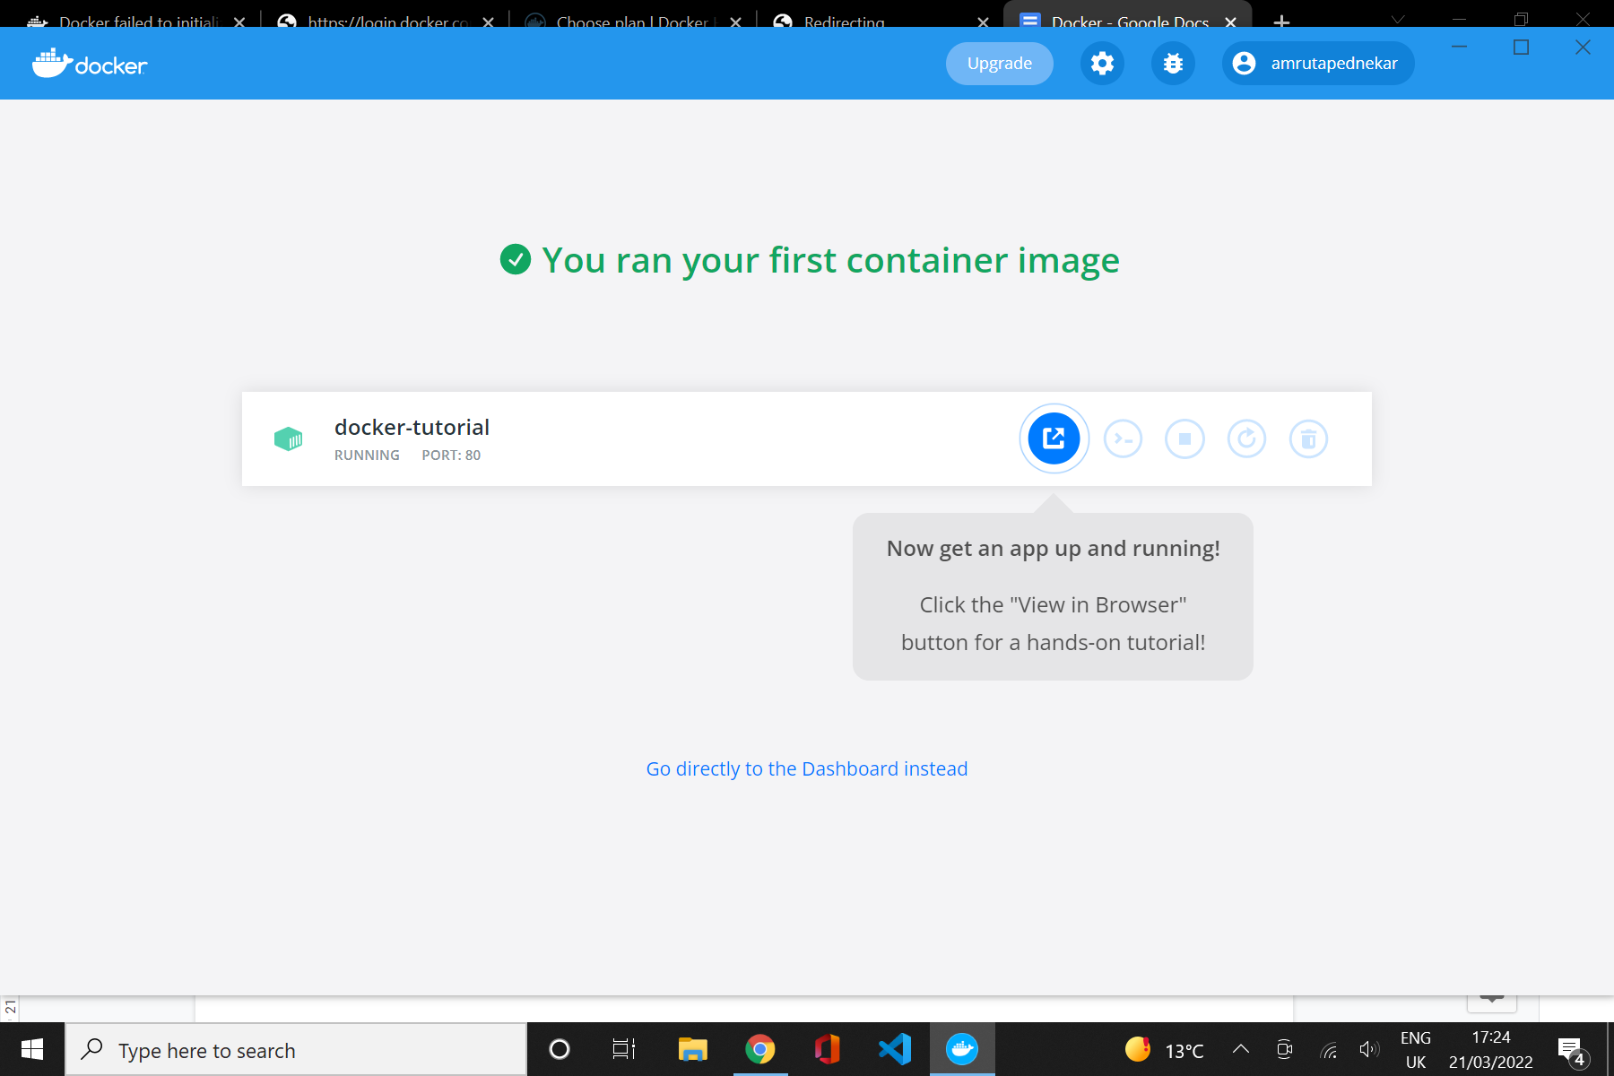

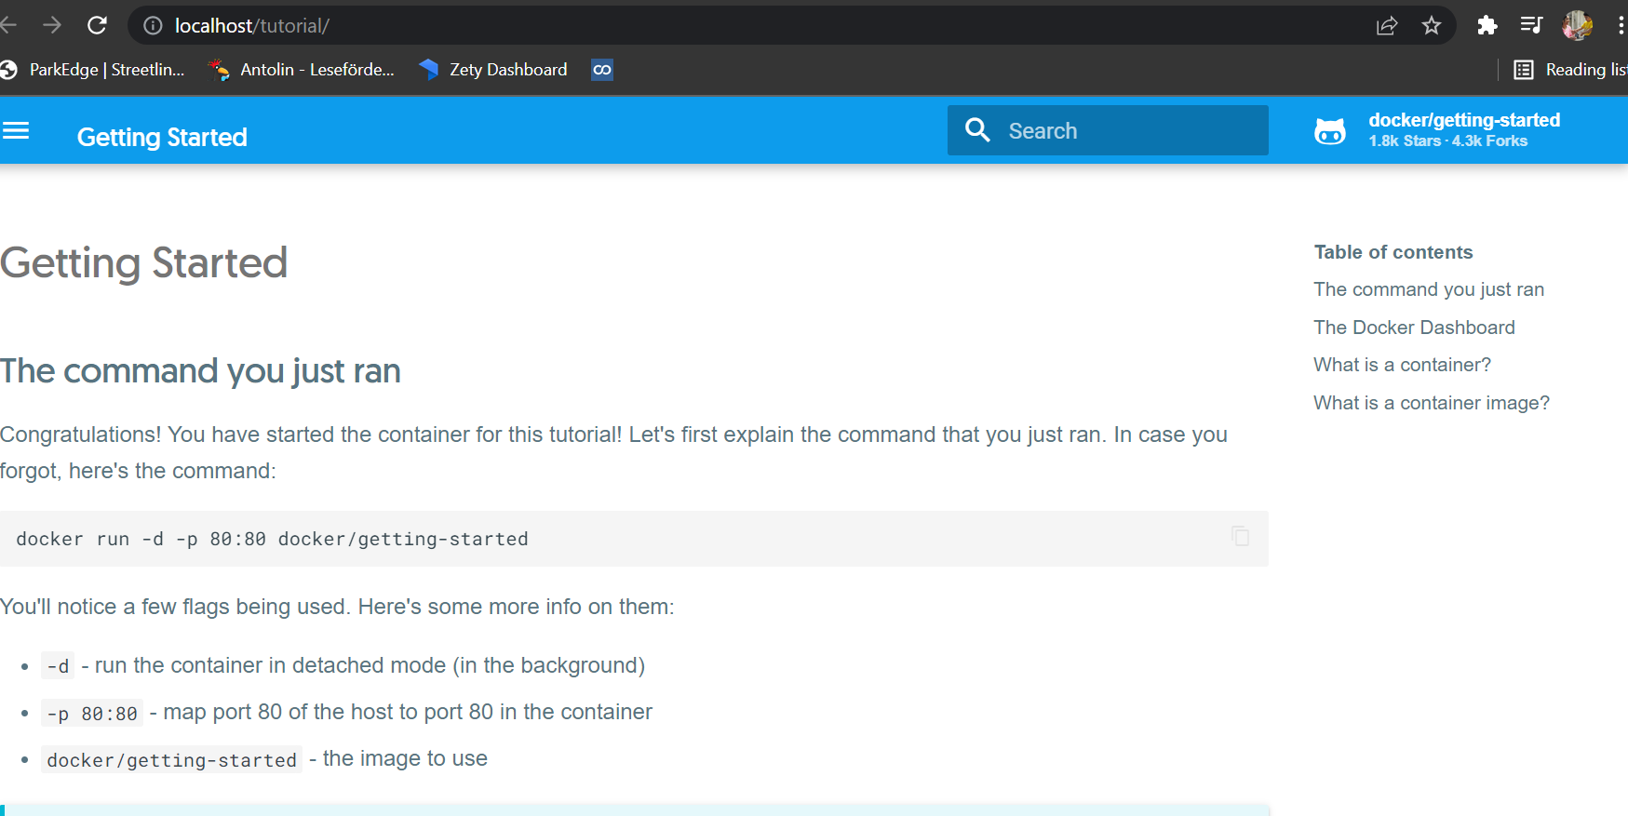

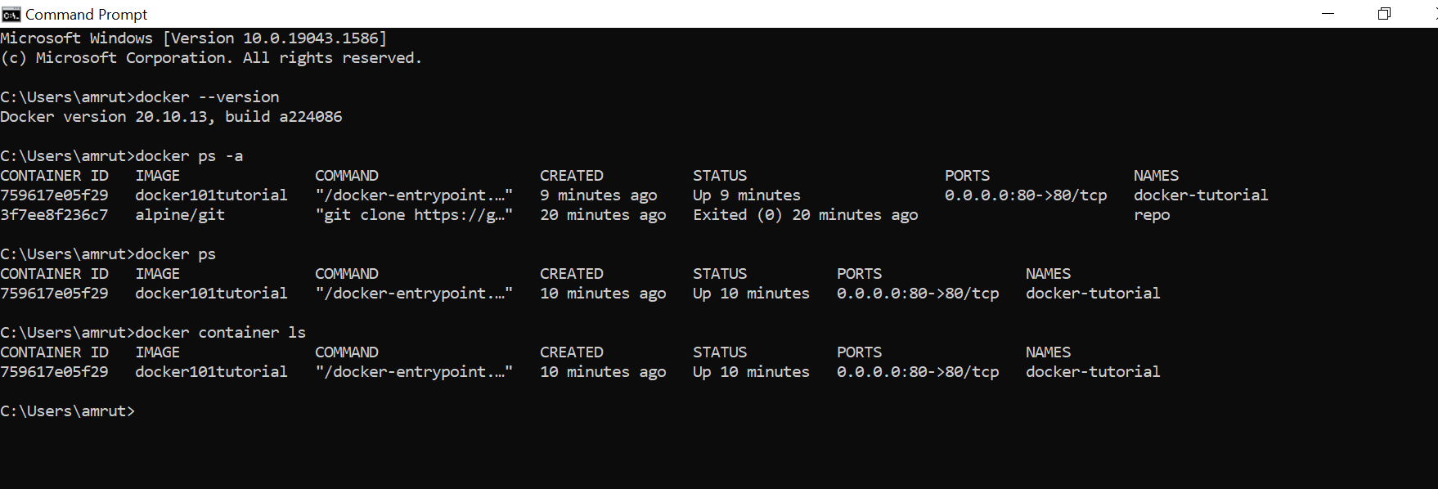

# Docker Commands List

<https://docs.docker.com/engine/reference/commandline/docker/>

docker — - help

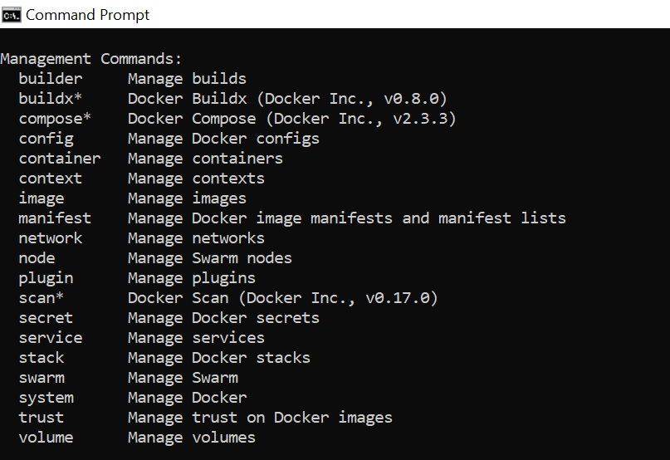

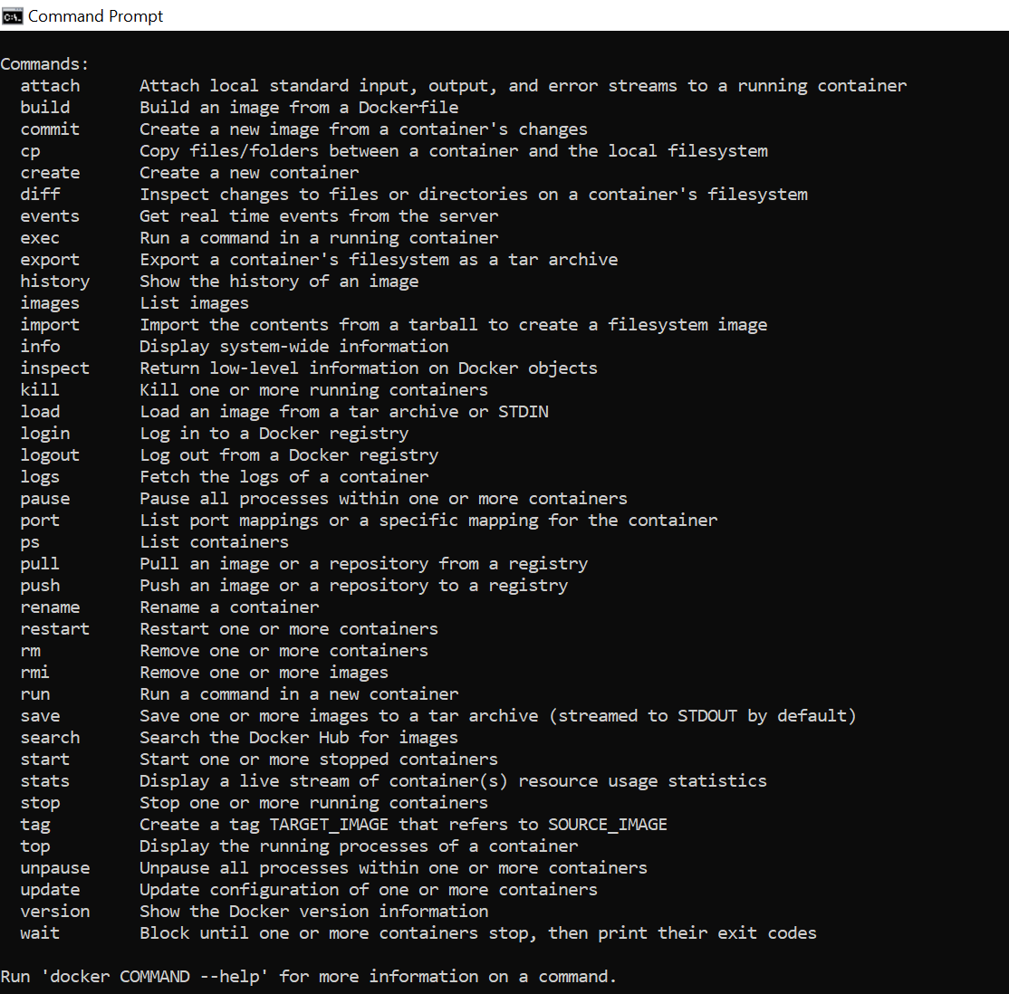

**Docker container commands**

docker container— - help

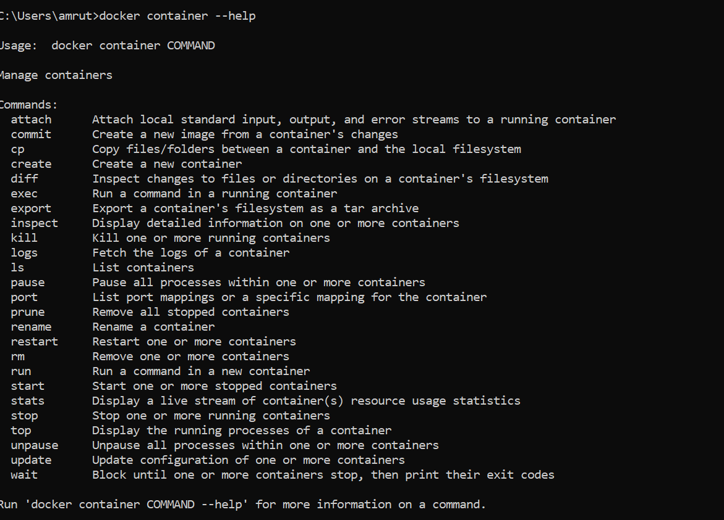

**Docker Image commands**

docker image — - help

